**CSE103L Circuits & Systems-I Lab**

**Circuits And System 1**

**LAB REPORT # 10**



2020

**Submitted to:**

**Engr. Faiz Ullah**

**Submitted by:**

**TAYYABA**

**Registration No:**

**19PWCSE1854**

**Semester: 2nd**

**Class Section: C**

“On my honour, as student of University of Engineering and Technology, I have neither given nor received unauthorized assistance on this academic work.”

Student Signature: ______________

Saturday, July 17, 2020

**Department of Computer Systems Engineering**

**University of Engineering and Technology, Peshawar**

# ASSESSMENT RUBRICS LAB # 10

**Mesh Current Analysis using PSPICE**

|  |  |  |  |  |
| --- | --- | --- | --- | --- |
| **LAB REPORT ASSESSMENT** | | | | |
| **Criteria** | **Excellent** | **Average** | **Nill** | **Marks**  **Obtained** |
| **1. Objectives of Lab** | All objectives of lab are properly covered [Marks 0.5] | Objectives of lab are partially covered  [Marks 0.25] | Objectives of lab are not shown [Marks 0] |  |
| **2. Mesh Current Analysis (Theory, Circuit Diagram )** | Brief introduction about Mesh Current Analysis (what is Mesh current analysis, What are meshes, How to apply KVL equations in each mesh) is shown along with properly labeled circuit diagram  [Marks 1] | Some of the points about Mesh Current Analysis are missing and circuit diagram is not properly labeled  [Marks 0.5] | Introduction about Mesh Current Analysis and circuit diagram is not shown [Marks 0] |  |
| **3. PSPICE**  **Simulator** | Brief introduction of PSPICE simulator [Marks 1] | Brief introduction of PSPICE simulator Is not shown  [Marks 0] | |  |
| **4. Procedure** | All experimental steps are shown in detail along with how to verify Mesh Current Analysis. [Marks 1.5] | Some of the experimental steps are missing [Marks 1] | Experimental steps are missing [Marks 0] |  |
| **5. Observations & Calculations** | Mathematical calculations are shown and comparison with PSPICE results. [Marks 5] | Mathematical calculations are shown but no comparison with PSPICE results [Marks 2.5] | No mathematical calculations are shown [Marks 0] |  |
| **6. Conclusion** | Conclusion about experiment is shown [Marks 1] | Conclusion about experiment is partially shown [Marks 0.5] | Conclusion about experiment is not shown  [Marks 0] |  |
| Total Marks Obtained:  Instructor Signature: | | | | |

# Verification of Mesh Current Analysis

**Objectives:**

Objectives of lab is to verify Mesh Current analysis.

# Mesh Current Analysis:

The Mesh Current Method is another well-organized method for solving a circuit. (The other is the Node Voltage Method.) As with any circuit analysis challenge, we have to solve a system of 2E2*E*2, E independent equations, where E*E*E is the number of circuit elements. The Mesh Current Method efficiently manages the analysis task, resulting in a relatively small number of equations to solve.

The Mesh Current Method is based on **[Kirchhoff's Voltage Law](https://www.khanacademy.org/science/electrical-engineering/ee-circuit-analysis-topic/ee-dc-circuit-analysis/a/electrical-engineering/ee-circuit-analysis/a/ee-kirchhoffs-laws) (KVL).** The [Loop Current Method](https://www.khanacademy.org/science/electrical-engineering/ee-circuit-analysis-topic/ee-dc-circuit-analysis/a/w/a/ee-loop-current-method) is a small variation of the Mesh Current Method. **How to apply KVL equation in mesh:**

The Mesh Current Method uses two special terms: *loop* and *mesh*.

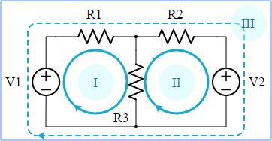

A *loop* is any closed path around a circuit. To trace a loop, you start at any component terminal, and trace a path through connected elements until you get back to the starting point. A loop is allowed to go through an element just one time (so you don't get loops that look like a figure.

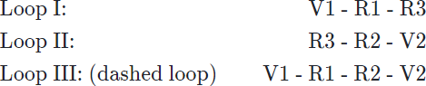In the circuit above, there are three loops, two solid loops, all the way around the outside. If we trace the loops in the clockwise direction, the three loops in our circuit go through

A *mesh* is a restricted kind of loop; a mesh is a loop that contains no other loops. In the circuit above, are *meshes* because there are no smaller loops inside. The dashed loop is not a mesh, because it contains two other loops. In the Mesh Current Method, we use the meshes of a circuit to generate KVL equations.

# PSPICE Simulator:-

**PSPICE** is a computer-aided simulation program that enables you to design a circuit and then simulate the design on a computer. As this is one of its main purposes, it is used extensively by electronic design engineers for building a circuit and then testing out how that circuit will simulate. There are a lot of things we can do with **PSPICE**, but the most important things for you to learn are

1. Design and draw circuits.
2. Simulate circuits.
3. Analyze simulation results.

# Procedure:

* 1. Open schematic program of **PSpice**
  2. Click on the “**Get New Part**” button on the toolbar
  3. Type ‘**r**’ in the search bar and place the **eight** resistors on the white sheet
  4. Type ‘**vdc**’ in the search bar and place **two** of them on the white sheet
  5. Type ‘**gnd-earth**’ and place it on the white sheet
  6. Now arrange these components on the white sheet according to the circuit diagram as following:

**|** P a g e

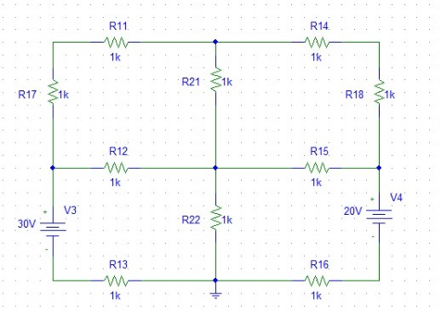

After arranging click on simulate button and the following results are generate

# Observation and Calculations:

While observing the circuit diagram we can find four different clock wise current loops in circuit:



LOOP 2

LOOP 4

LOOP 3

LOOP 1

## For 1st loop:

**- (1000)*I1* – (1000)(*I1-I2*) – (1000)(*I*1-*I*3) – (1000)*I*1 = 0**

**- 1000\**I*1 - 1000\**I*1 + 1000\**I*2 – 1000\**I*1 + 1000\**I*3 – 1000\**I*1 = 0**

**- 4000\**I*1 +1000\**I*2 + 1000\**I*3 = 0** →**(a).**

## For 2nd Loop:

**- (1000)*I*2 – (1000)*I*2 – (1000)(*I*2-*I*4) – 1000(*I*2-*I*1) = 0**

**- 1000\**I*2 – 1000\**I*2 – 1000\**I*2 + 1000\**I*4 – 1000\**I*2 + 1000\**I*1 = 0**

**- 4000\**I*2 + 1000\**I*4 + 1000\**I*1 = 0** →**(b).**

## For 3rd Loop:

**- (1000)(*I*3-*I*1) – (1000)(*I*3-*I*4) – (1000)*I*3 + 20 = 0**

**- 1000\**I*3 + 1000\**I*1 – 1000\**I*3 + 1000\**I*4 – 1000\**I*3 + 20 = 0**

**- 3000\**I*3 + 1000\**I*1 +1000\**I*4 = -20** →**(c)**

## For 4th Loop:

**- (1000)(*I*4-*I*2) + 10 - (1000)*I*4 – (1000)(*I*4-*I*3) = 0**

**- 1000\**I*4 + 1000\**I*2 + 10 – 1000\**I*4 – 1000\**I*4 + 1000\**I*3 = 0**

**- 4000\**I*4 + 1000\**I*2 +1000\**I*3 = -10** →**(d)**

Writing Equation (a), (b) , (c) & (d) in matrix form:

## Equation Form:

**-4000*I*1 + 1000*I*2 + 1000*I*3 + 0*I*4 = 0**

**+1000*I*1 - 4000*I*2 + 0*I*3 + 1000*I*4 = 0**

**+1000*I*1 + 0*I*2 – 3000*I*3 + 1000*I*4 = -30 0*I*1 +1000*I*2 + 1000*I*3 – 3000*I*4 = -20**

## Matrix form:

-4000 1000 1000 0 0

1000 4000 0 1000 0

=

1000 0 -3000 1000 -30

0 1000 1000 -3000 -20

After solving this matrix using calculator we get the values:

## *I*1 = 2.316 mA

## *I*2 = 315.79 uA

## *I*3 = 9.58 mA

***I*4 = 3.579 uA**

# Conclusion:

After comparing the values we get using Mesh Current Analysis and Pspice software, there wasn’t a single difference hence verified,

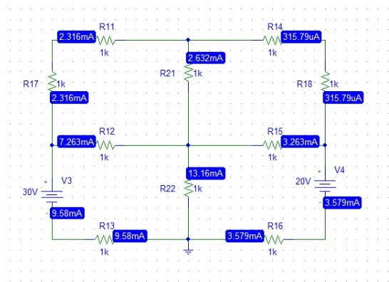

|  |  |  |
| --- | --- | --- |
| **Current** | **PsPice Current** | **Mesh Current** |
| **1** | 2.316 mA | 2.316 mA |
| **2** | 315.79 uA | 315.79 uA |
| **3** | 9.58 mA | 9.58 mA |
| **4** | 3.579 uA | 3.579 uA |